3/23/2022

Chirag Gaur

Deloitte

KT Session

on

**PingDirectory**

**Table of Contents**

|  |  |  |
| --- | --- | --- |
| **S. No** | **Topic** | **Page No.** |
| 1. | Introduction to Directory | 2 |
| 2. | Directory vs Database | 2 |
| 3. | What is LDAP?  3.1 Entry  3.2 Directory Information Tree  3.3 Distinguished Name  3.4 Object Class | 2  2  2  3  3 |
| 4. | PingDirectory Folder Configuration | 4-5 |
| 5. | PingDirectory Basics Commands | 6 |
| 6. | LdapSearch | 7-8 |
| 7. | LdapModify | 9-10 |
| 8. | PingDirectory Installation Guide   1. Setting Up Virtual Machine 2. Downloading JAVA 3. Downloading License files 4. PingDirectory Installation | 11  11  12  13-17 |

1. **Introduction to Directory**

* Directory is a hierarchical structure that is used for searching and reading information.
* It is more optimized for reading rather than writing. It means that in a directory maximum operation performed will be of type read.
* The major purpose of directory is store attributes such as name, location, user id etc. It not only stores info about people but also about physical devices on a network such as printers, routers, PC’s etc.

1. **Directory Vs Database**

* Directory provides a simple way of accessing resources whereas Database are used for transactions with more write to read ratio.
* In directory objects are stored in hierarchical form whereas in Database objects are stored in tables form comprised of rows and columns.
* Directory provides a way to authenticate the identity by using LDAP protocol.

1. **What is LDAP?**

* LDAP stands for Lightweight Directory Access Protocol.
* As the name suggests the operations are much faster as compared to Relational databases.
* It is a client server based standard protocol which is used to connect with directory.

**3.1 Entry**

* LDAP entry is a collection of information about an entity.
* Each entry consists of three components which includes distinguished name, collection of attributes and collection of object classes.

**3.2 Directory Information tree (DIT)**

* DIT is a hierarchal structure which represents the entries of organization.
* It is also called as namespace or LDAP tree.

**3.3 Distinguished Name (DN)**

* Distinguished name of an entry identifies the unique path of an entry in Directory information tree. It is comprised of attribute-value pairs.
* It is just like the path of the file in the filesystem.

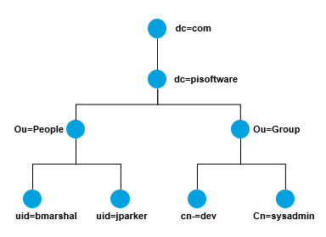

* In above diagram distinguished name example can be:

Cn=dev, ou=group, dc=pisoftware, dc=com

Top Is the parent object class

-s scope : it tells how deep we need to do the search

-s 1 : at level 1 searches from the ou=people

-s 2: at level 2 searches from the entire directory

**3.4 Object Class**

**Is used to define the str of entries that what set of attributes has.**

**Attributes added for an object class are added in schema.**

**Each object class allows some attributes which can be seen in schema file.**

* Object class is used to group related information.
* It maps real world entities to objects such as Person or a printer**.**
* Eg: object class: Person
* cn: Chirag; c: India

1. **PingDirectory folder configuration**

* The PingDirectory installation path would have folders such as bat, bin, collector, config etc.
* The utilities of major folders are described below.

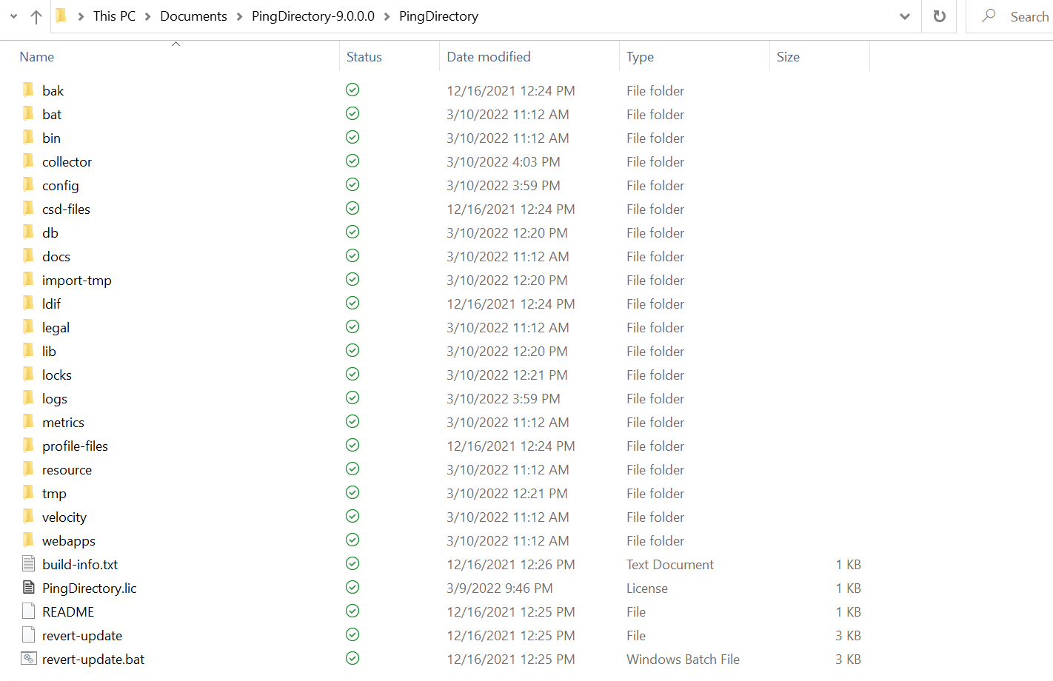

1. Bat folder- Command line utilities for Windows Operating System.
2. Bin folder- Command line utilities for Linux Operating System.
3. Config Folder- It consist of important folders/files:
4. Schema Folder- It comprised of files which contains attributes and object class for defining entry. Custom attributes can also be created
5. Config file- It stores all the information about directory. This is one of the most important files. The extension of this file is ‘.ldif’.
6. Db Folder- In the backend, there Is a database that actually interacts using LDAP.

* All the database files are stored in directory.
* Cache is stored here.

1. Log Folder - It consist of following log files:
2. Access Log- It consists of information regarding:

* All operations performed with entries in Directory like adding, deleting, create etc. But attributes will not be present here for user only its DN.
* Error regarding Wrong password entered will be present here.
* Its purpose is to check whether Authentication was successful or not as it contains request and error code for unsuccessful Authentication.

1. Error Logs- These are important for administration server as it will contain information regarding:

* High Resource Utilization
* Memory full
* Restart of any instance

1. Audit Log – Modifications done to the directory server like addition, deletion etc. Attributes for the user will be also present here.

**Hands-on Documentation**

**on**

**PingDirectory**

1. **PingDirectory Basic Commands**

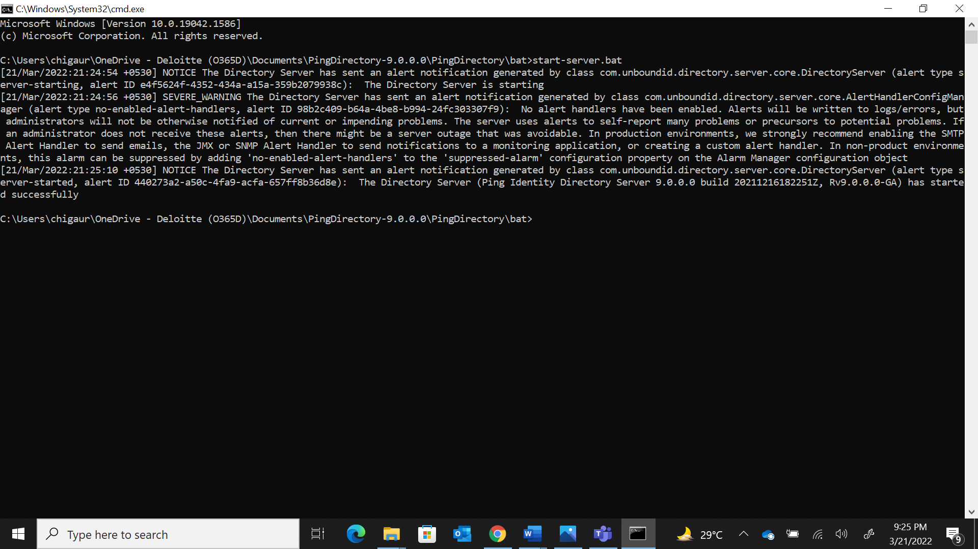1.1 **start-server.bat** command is used to start the ping directory server**.**

1.2 **stop-server.bat** command is used to stop the ping directory server.

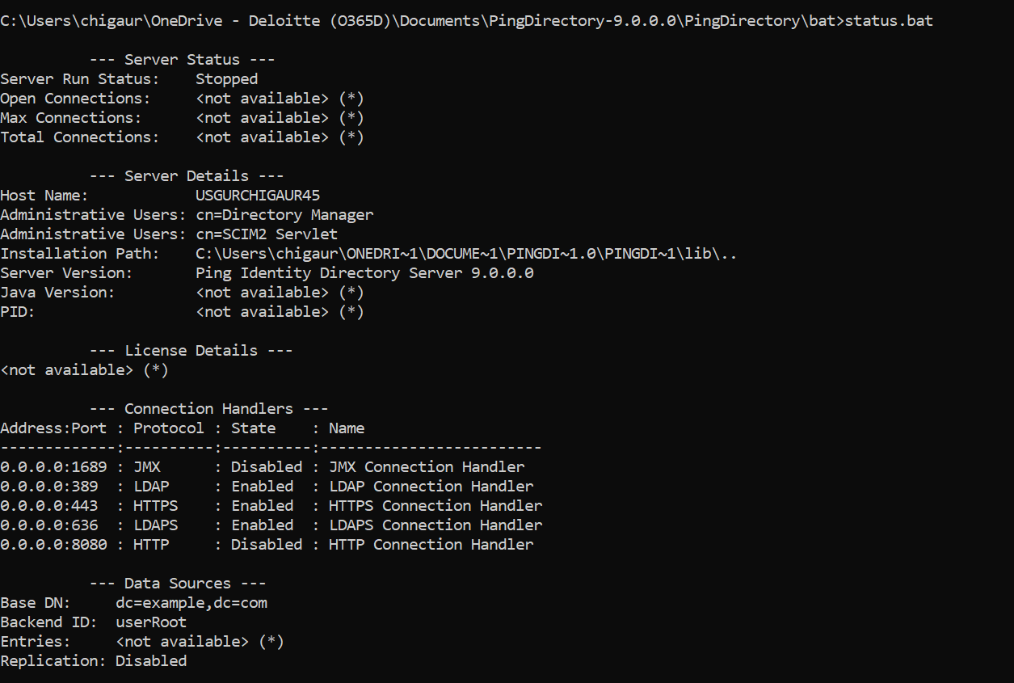1.3 **stauts.bat** command is used to generate information about configuration and status of server.

1. **Search Operation**

This command is used to search for an account. Using this command, we can also define the information we want to fetch for the particular account.

Example 1: How to retrieve all the entries using search command?

* The Command used is **ldapsearch.bat -h localhost -p 389 -D cn="Directory Manager" -b dc=example,dc=com uid=\***

Where

* -h stands for hostname
* -p for port number
* -D for Binding DN i.e. connect to directory
* -b is base/root
* 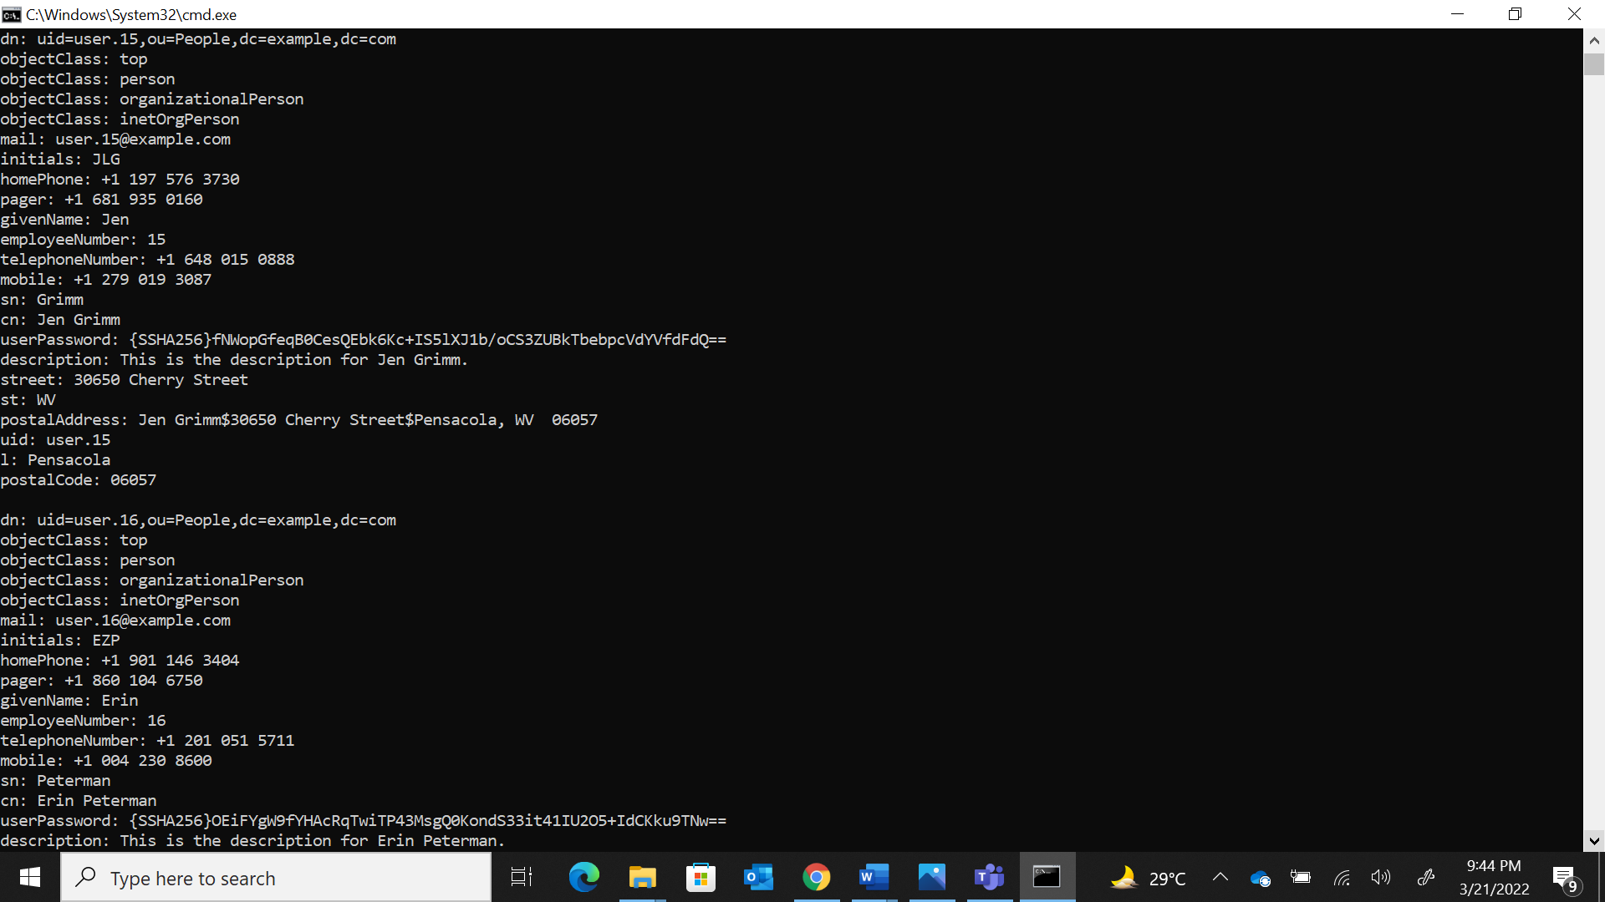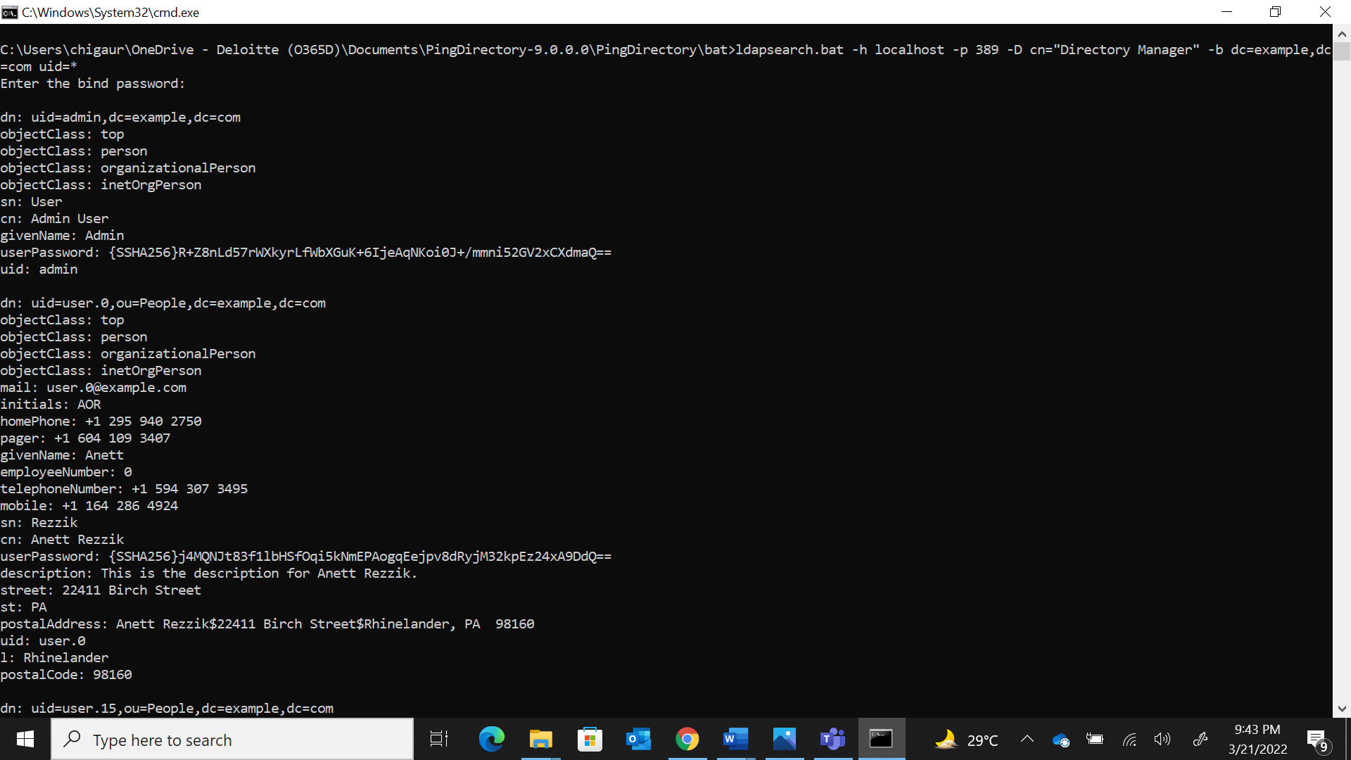uid is the user id for which we are searching

Example 2: How to filter the entries using search command?

* The Command used is **ldapsearch.bat -h localhost -p 389 -D cn="Directory Manager" -b dc=example,dc=com uid=user.0**
* In this example user attributes-value pair will be returned having id as user.0

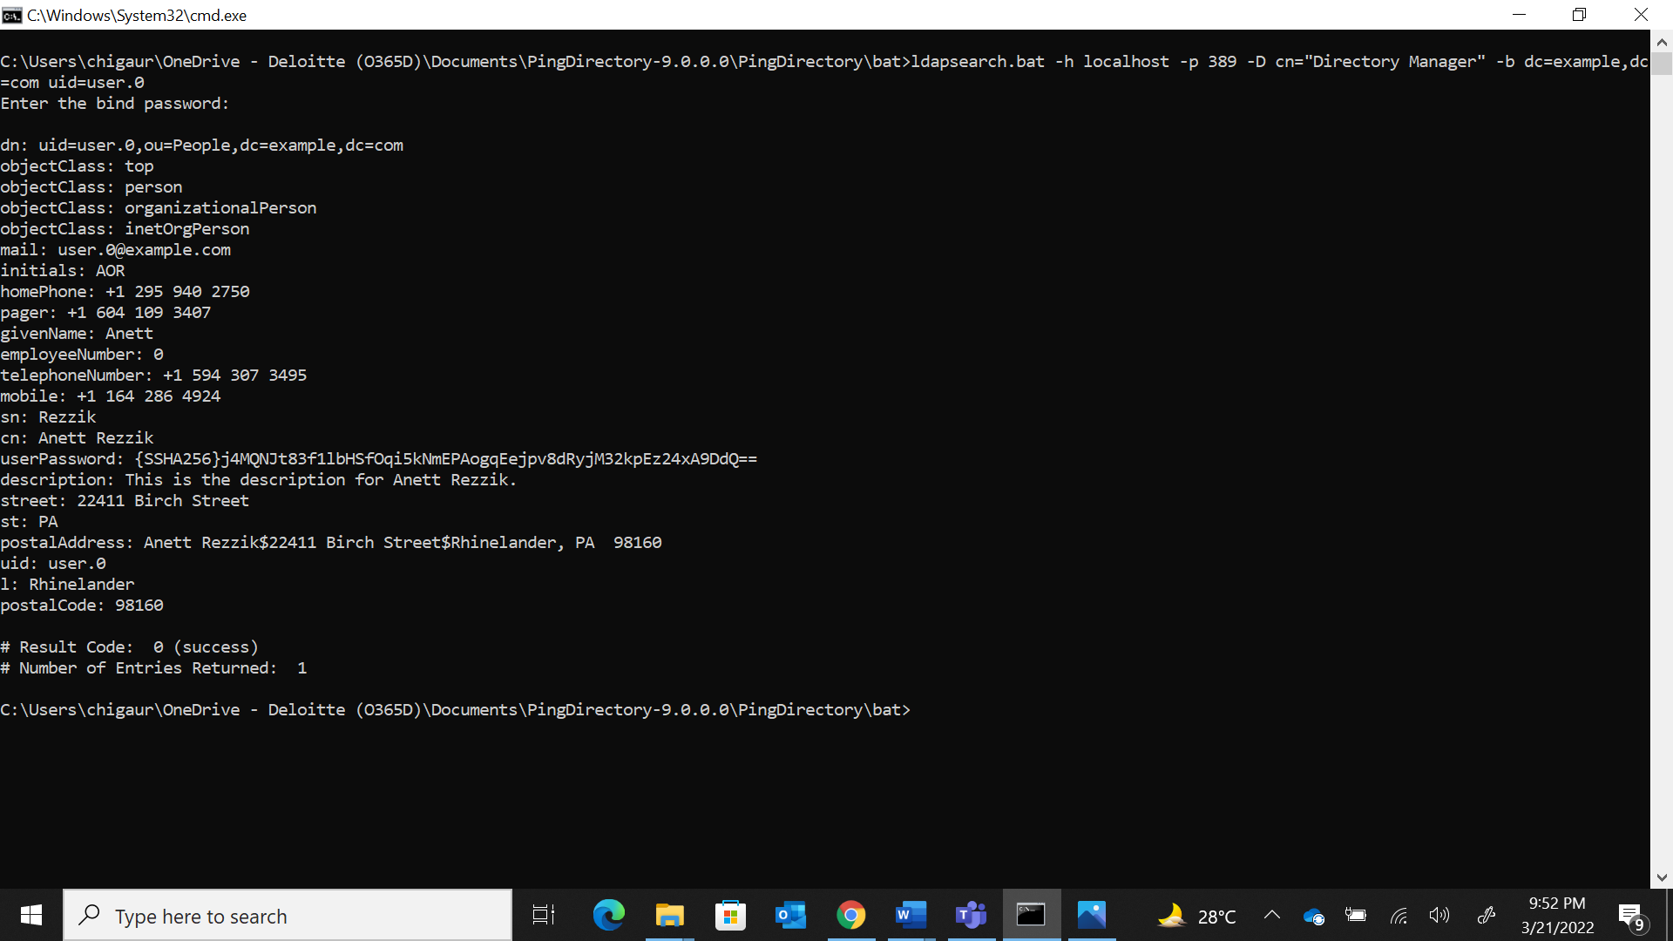

Example 3: How to filter entries and return selective attributes of that entry?

* The Command used is **ldapsearch.bat -h localhost -p 389 -D cn="Directory Manager" -b dc=example,dc=com uid=user.0 mail cn**
* 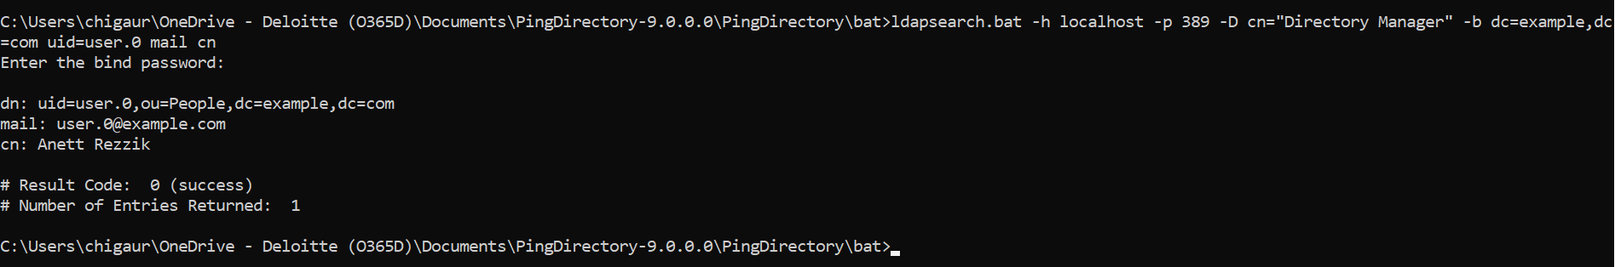This command will return the attribute values of mail and cn of entry with uid as ‘user.0’.

1. **Modify Operation**

* Ldapmodify is used to modify the attributes values of one or more than one user accounts.
* General Command for modify LDAP operation is **ldapmodify -h localhost -p 389 -D cn=’Directory Manager’ -f "file_path"**

Example 1: How to modify attribute such as email and cn of an entry?

* The Command used is **ldapmodify -h localhost -p 389 -D "cn=Directory Manager" -f "C:\Users\chigaur\OneDrive - Deloitte (O365D)\Documents\sample.ldif"**
* Here file ‘sample.ldif’ stores the changes made to an entry with uid as ‘user.16’

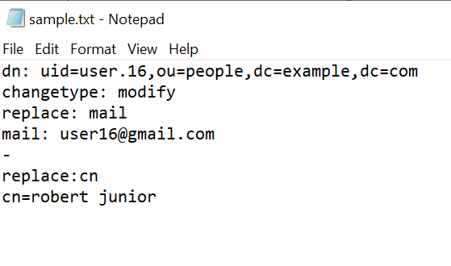

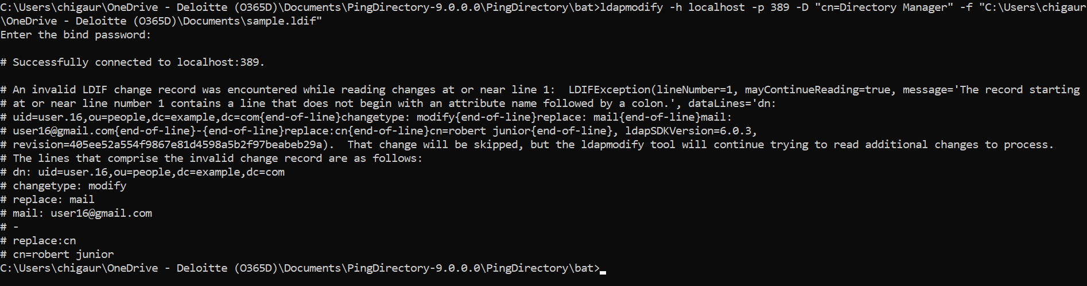

Example 2: How to modify attributes of multiple entries in a single ldif file?

Command is **ldapmodify -h localhost -p 389 -D "cn=Directory Manager" -f "C:\Users\chigaur\OneDrive - Deloitte (O365D)\Documents\test.ldif"**

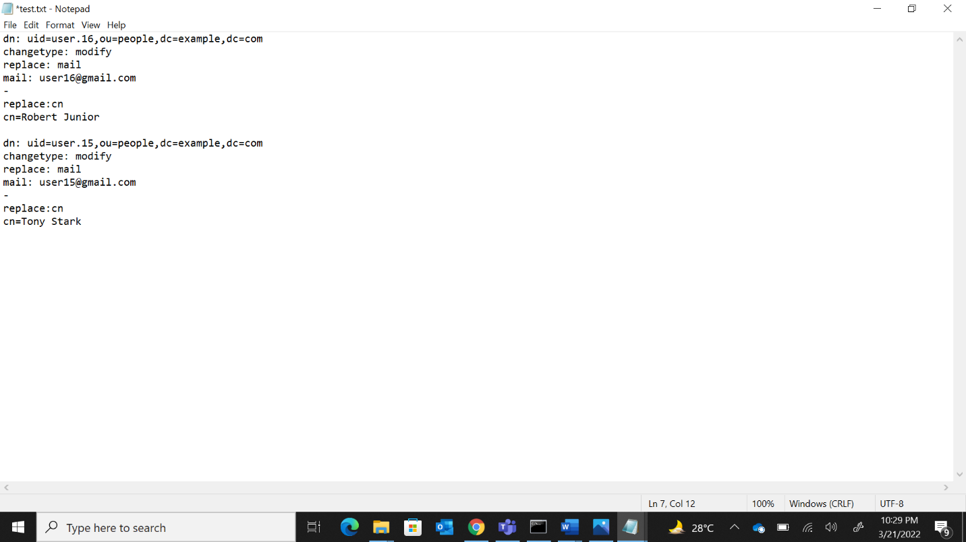

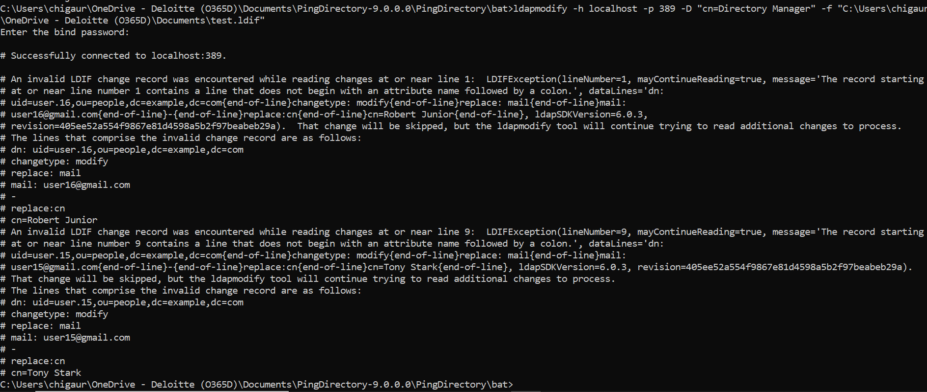

How to create a user account in Ping Directory?

**PingDirectory Installation Guide**

# Setting up a Virtual Machine

Download any Virtual Machine Software and set up any Linux distribution of your choice.

* Virtual Machine - VMware Workstation
* Linux Distro - Ubuntu

# Downloading JAVA

PingDirectory requires a Java runtime to be installed on your server and has been tested in the following Java environments:

* Amazon Corretto 11
* Amazon Corretto 8
* OpenJDK 11
* Oracle Java SE Development Kit 11 LTS
* Oracle Java SE Runtime Environment (Server JRE) 8

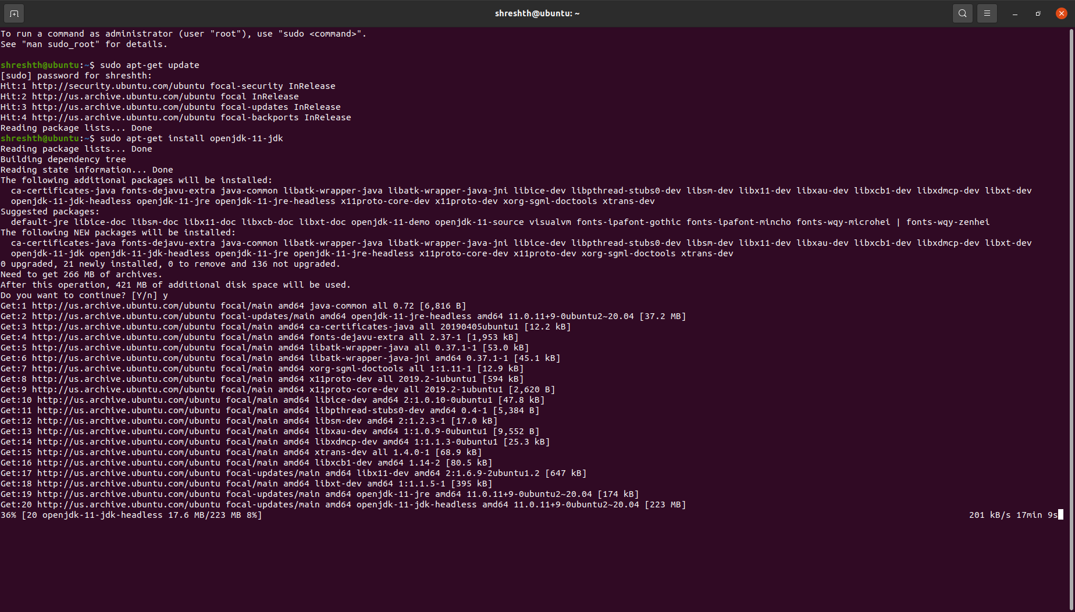One can install OpenJDK 11 on an Ubuntu by running **sudo apt-get install openjdk-11-jdk** in the terminal

# Downloading License Files

Request your license files for PingAccess, PingFederate and Ping Directory, one at a time, on this URL <https://www.pingidentity.com/en/account/request-license-key.html>

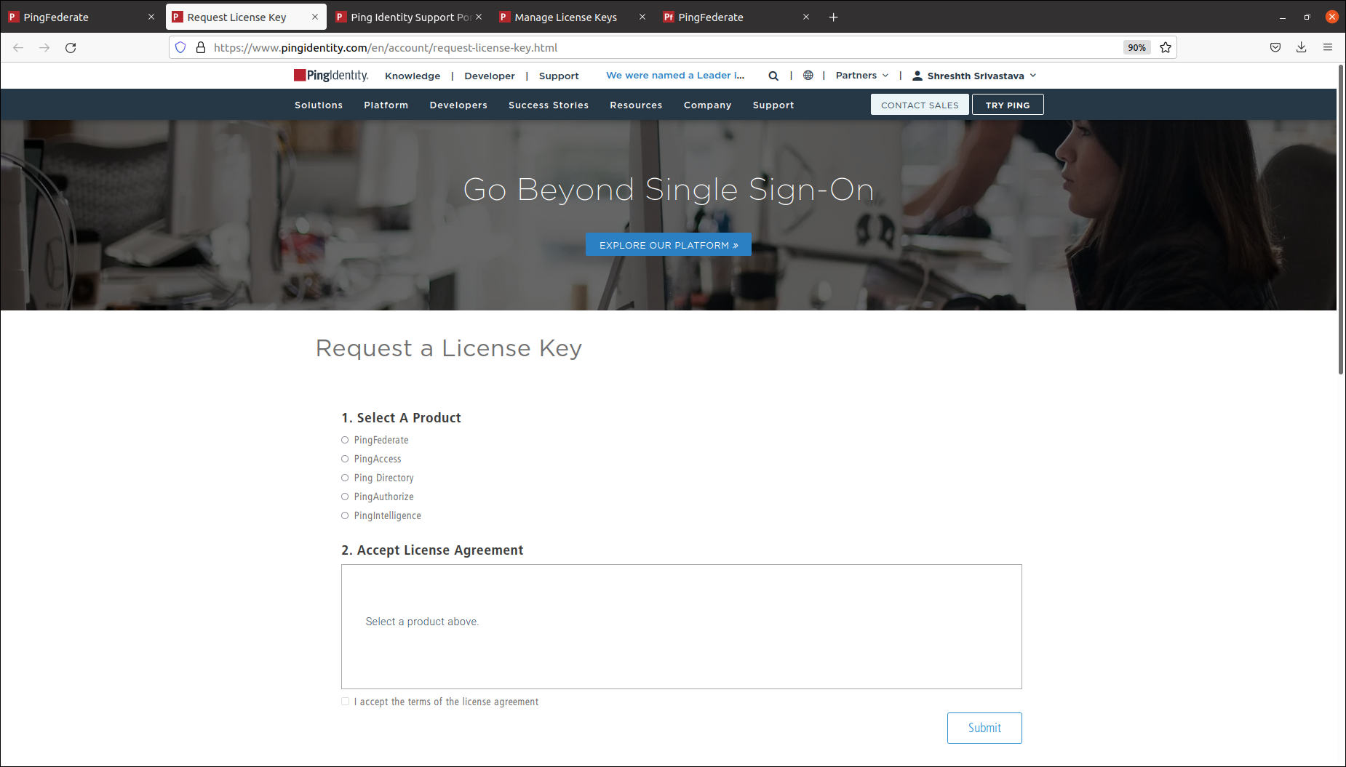

Once requested for all three license keys, download them by going to the Support Dashboard from this URL <https://support.pingidentity.com/s/>

Click on **MANAGE LICENSE KEYS → VIEW → DOWNLOAD** and download all the three requested license files respectively

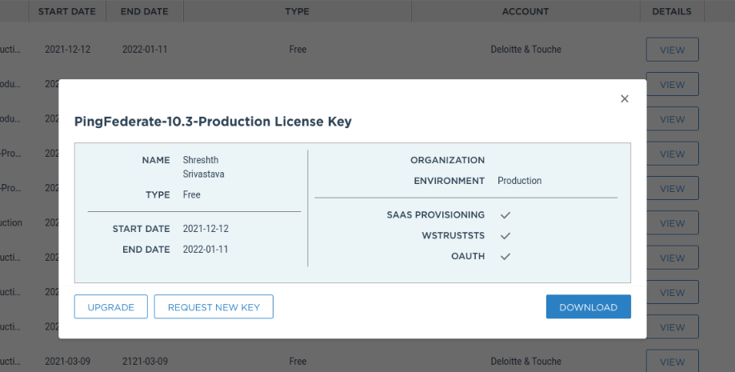

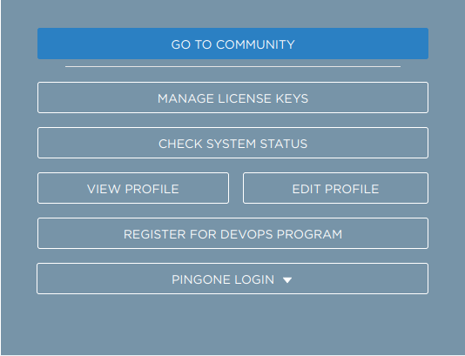

# 4. Ping Directory Installation

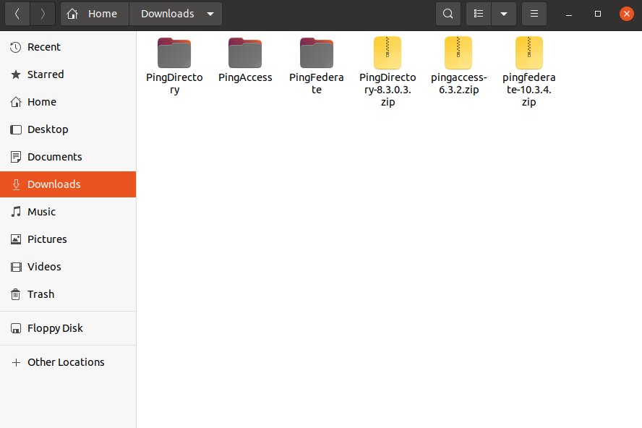Go to the URL <https://www.pingidentity.com/en/resources/downloads/pingdirectory-downloads.html> and download the Linux-based Product Distribution (ZIP) file.

Inside the ping directory folder, open a terminal and run the commands as shown in the figure below to begin ping directory installation

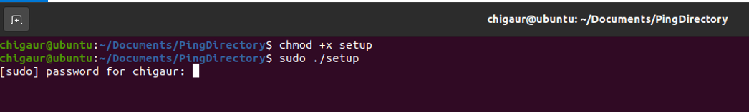

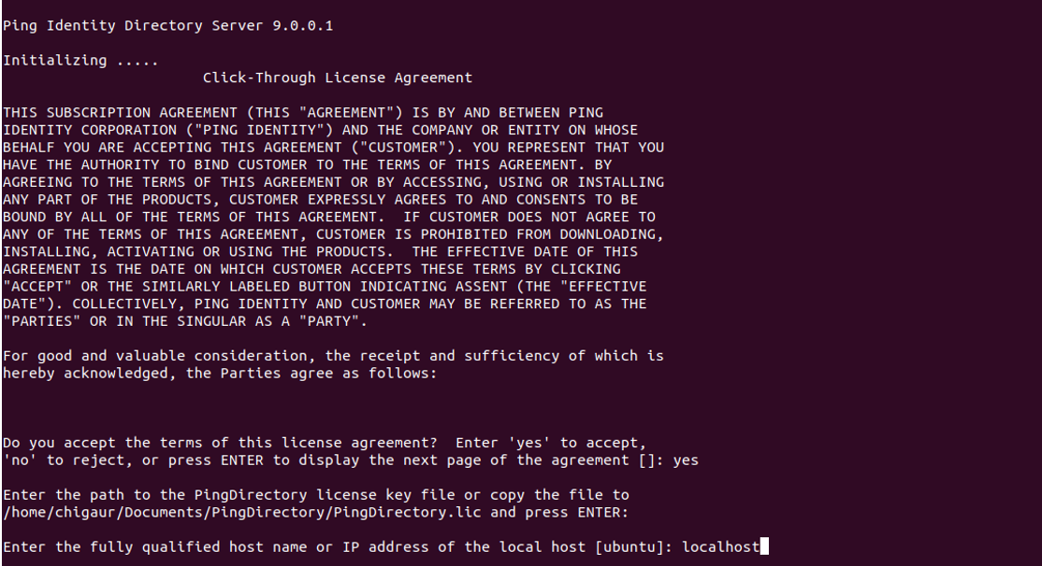Copy the acquired license file for ping directory to the location mentioned and continue following the instructions

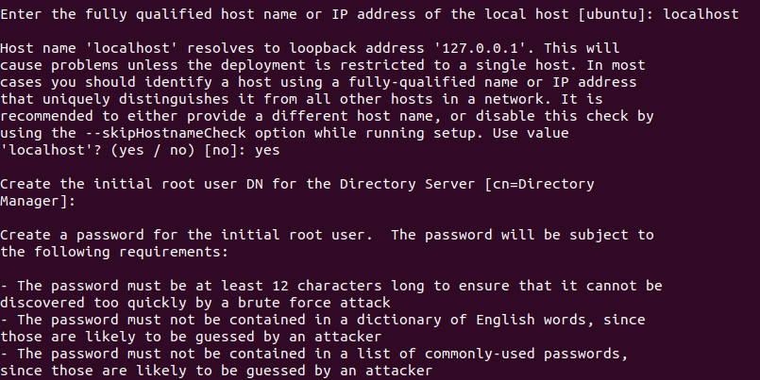



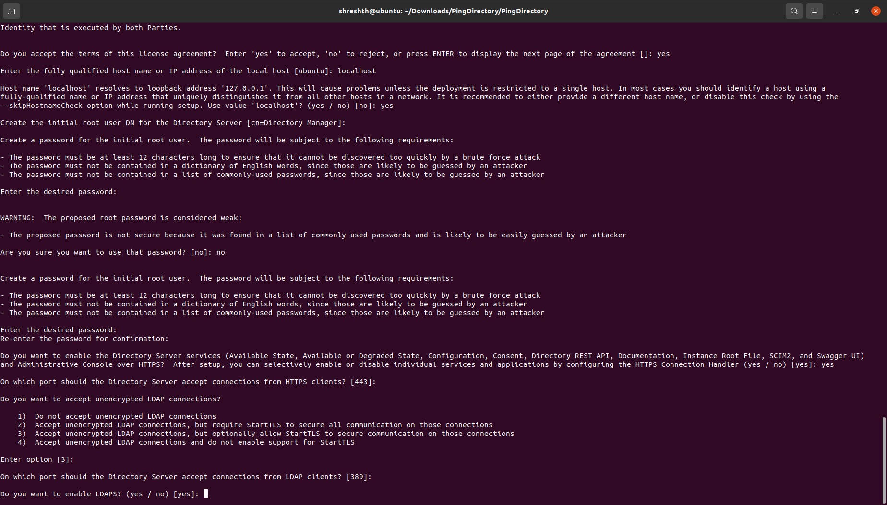

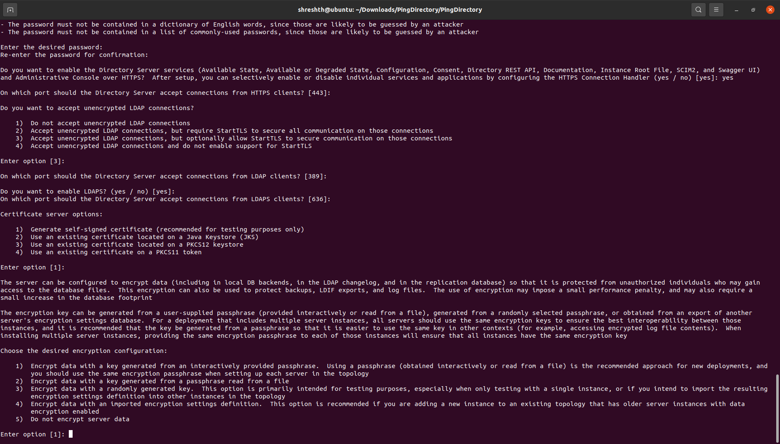

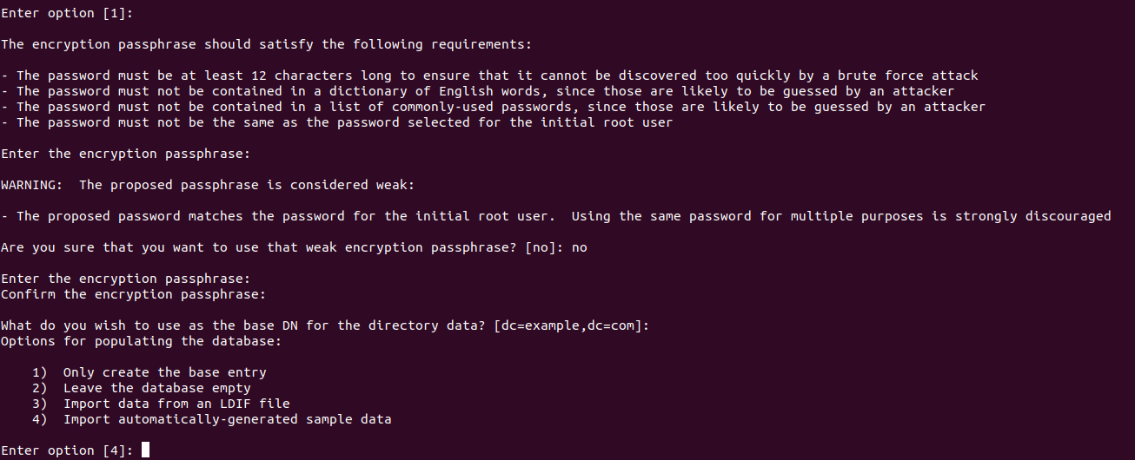

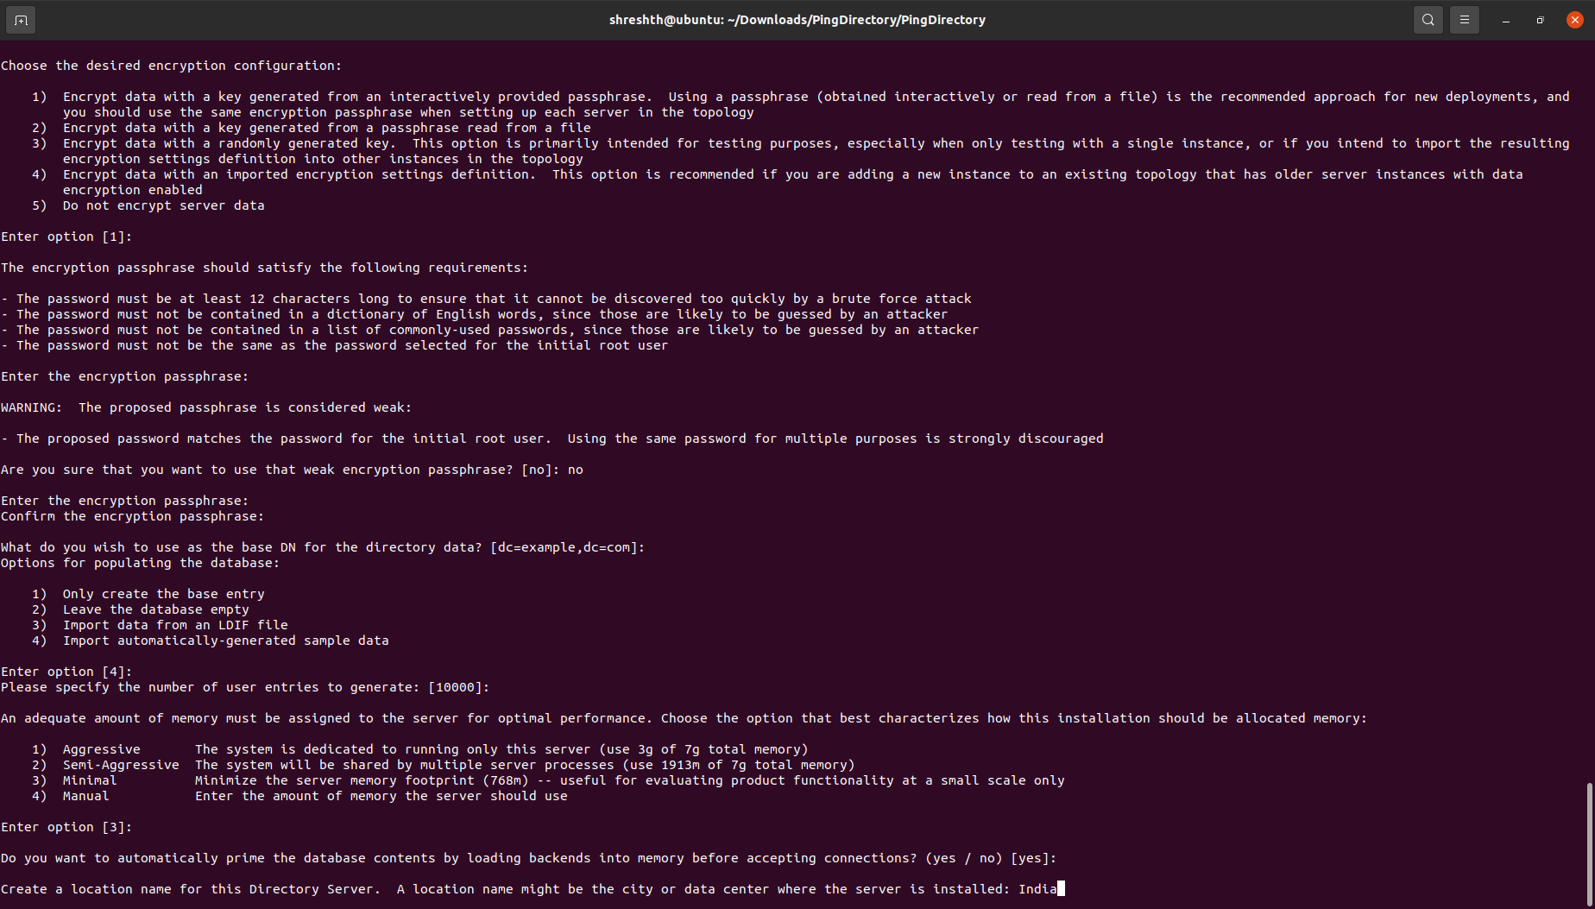

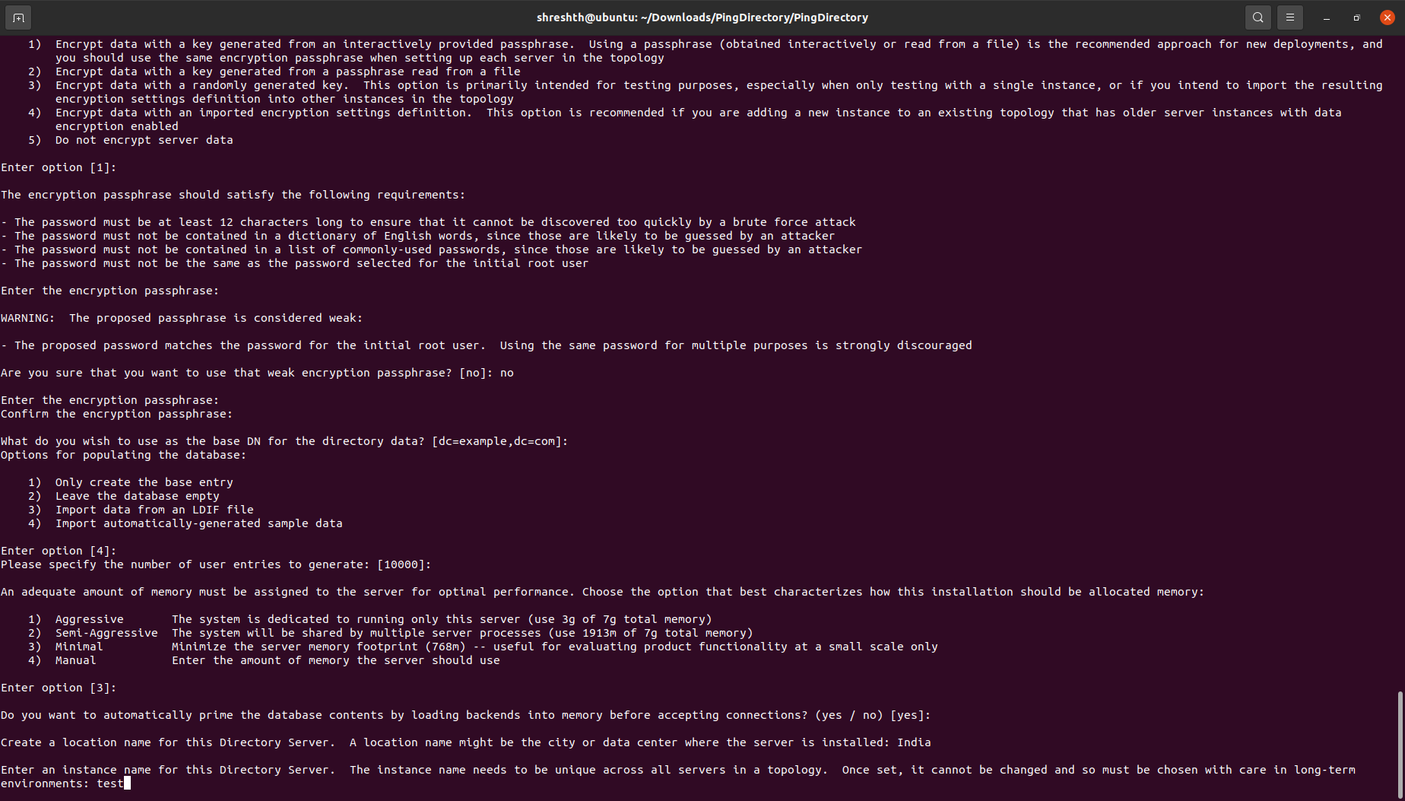

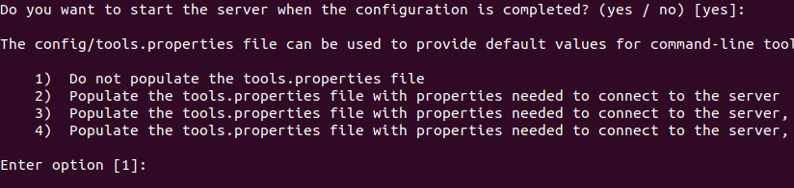

Final Configuration would look as below:

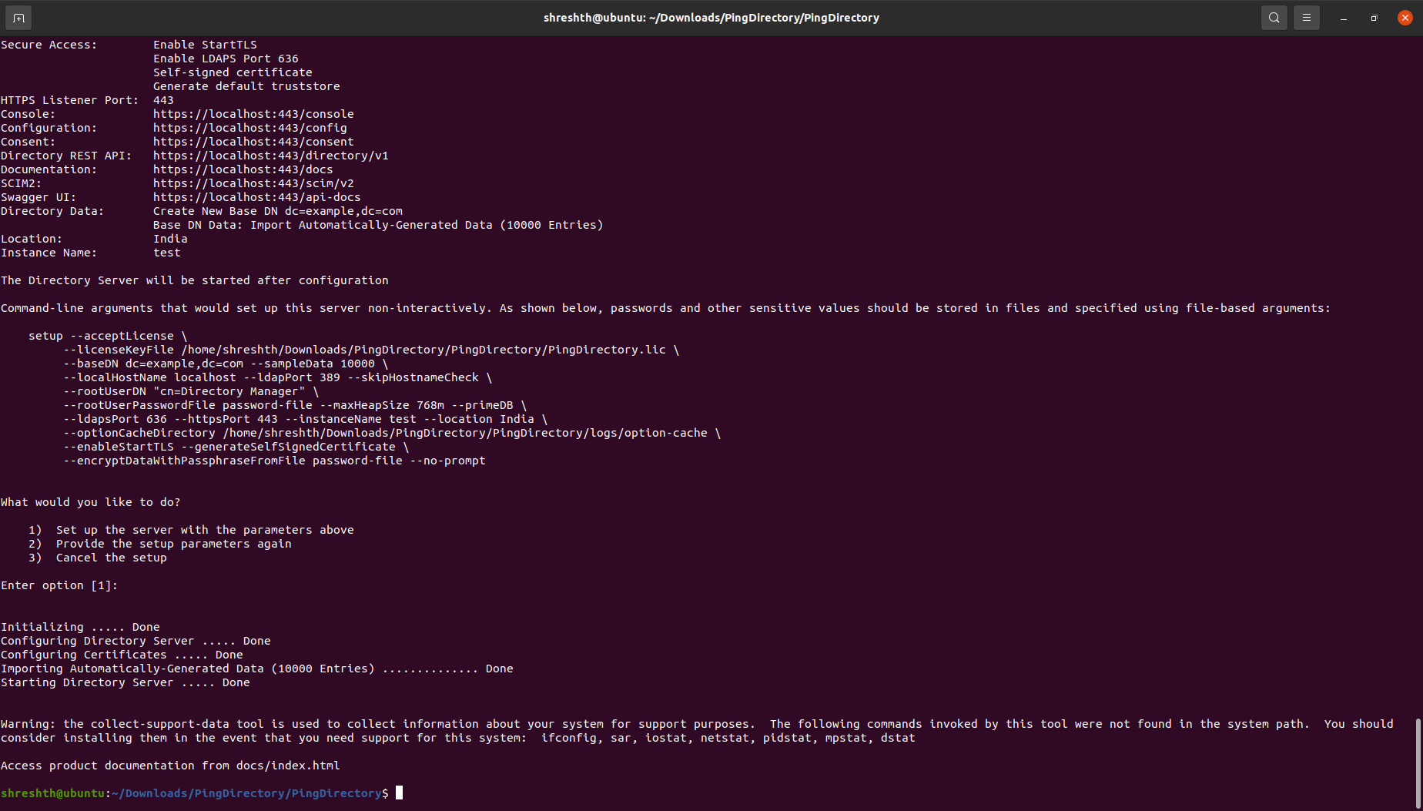

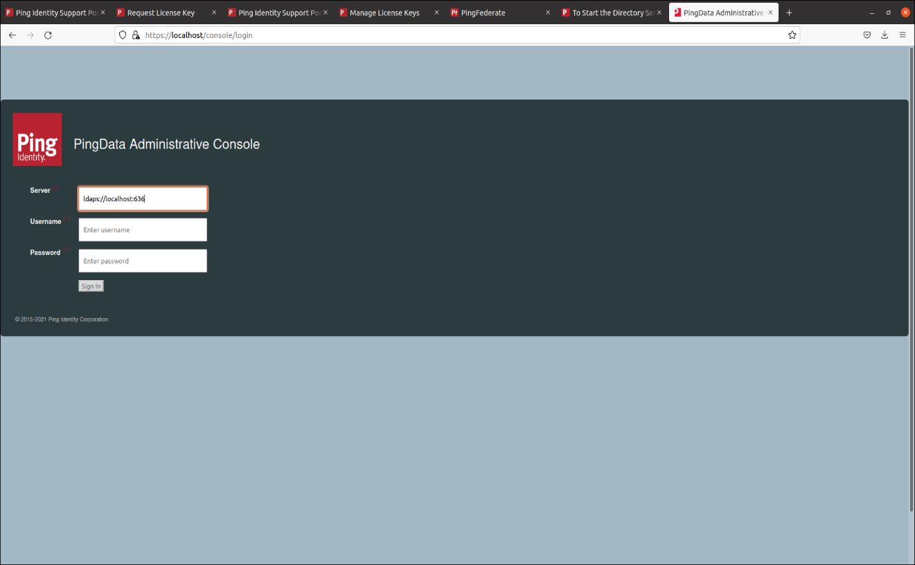Open <https://localhost:443/console> to open ping directory console